66 Furlong Street
Arnold
Nottingham
NG5 7BP

Tel No: 0115 9673777

Welcome to Stenhouse Medical Centre. Please find attached a GMS1 registration form together with our new patient questionnaire for completion.

Please complete the GMS1 form completing all sections and make sure your NHS number is on the form; this is a ten digit number.

The New Patient Questionnaire must be completed as fully as possible to enable us to process your registration quickly and efficiently. This information will help us manage your care until your records arrive and will enable us to recommend interventions to ensure your long-term health. We also require you to provide two forms of identification. Please see the form which gives details on what I.D. we require.

If you receive regular medications from your previous GP a repeat prescription reordering slip must be attached to this form. You will need to contact the practice to arrange a telephone appointment with a clinician in order for your medication to be issued (please allow 72 hours for your prescription to be processed), if you do not book this appointment there will be a delay in issuing your medications. You can also sign up to our electronic prescription service which enables you to order your prescriptions on line 24 hours a day – 7 days a week and to compliment this service you can nominate a pharmacy of your choice to have your prescription sent electronically so you won’t need to come in to surgery to collect it. All you need to do is bring in two forms of identity and then a Receptionist will be able to issue you with a username and password.

Once you have completed all the forms please hand them in at the reception.

All patients registering with the practice are entitled to a New Patient Check. If you wish to have a check please contact the practice to book a 15 minute appointment.

Did you know you can book and cancel appointments, order prescriptions and set organ donation preferences on the new NHS app? This is now available to download on the Google Play and Apple app store. Would you like us to send SMS messages regarding your appointments and other communications? If so, you can now download the MJOG smart app on Google Play and Apple App Store for more integrated communications and features. This is free for both yourself and the surgery.
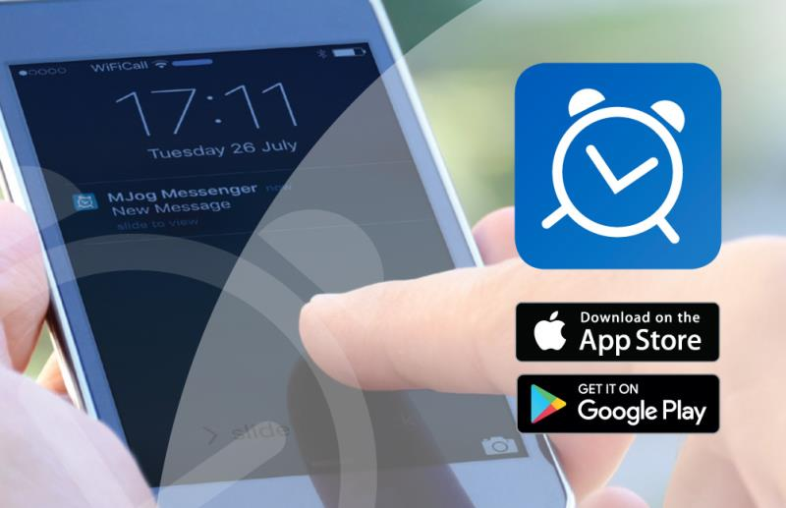
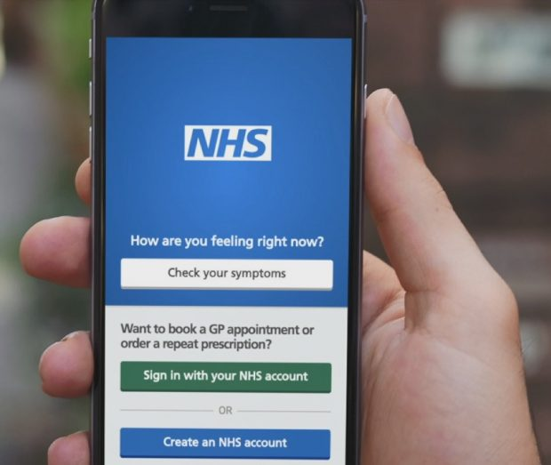

How to Register with the NHS App

Please see the link on the website to a video of how to download the NHS App or read the below guidance

How to register with the NHS App
Download the NHS app from google play or app store.
A patient will only need to prove who they are once to access multiple services through the NHS login.
When they click the NHS app button, the patient will be asked to:
- Give their email address
- Choose a password
- Accept the NHS login terms and conditions

They will then receive an email containing a link. They must click this link to confirm their email address. They will then see a page telling them they now have an NHS login.
The patient will need to return to the app and enter their NHS login email address and password. They will now be asked to give their mobile number. A six-digit security code will be sent by text message to their mobile number. They will be prompted to enter this code and press continue.
Next, the patient will need to confirm their identity so they can have secure access to their health information.
They can use the registration details from their GP practice’s online service or submit photo ID and a short video.
The accepted types of photo ID are:
- Passport
- UK driving licence, either full or provisional
- A full European driving licence
- European national identity card
Using registration from GP practice
The patient will need to contact their GP practice and ask for their online services details. The patient will be given 3 registration details:
- A linkage key
- An ODS code
- An account ID
Using photo ID and video
The patient will be asked:
- Take a photo of their ID and submit it
- Record a short video of their face as they say 4 numbers
- Enter their date of birth
- Enter their NHS number if they know it
- If they don’t, enter their name and the postcode of their home address s registered with the practice
Following submission, the patient’s identity will be carefully checked and should be verified within 2 hours. If they submit between 9pm and 9am it may take longer. The patient will be emailed to let them know if the ID check has been successful.
If you would like this letter or information in an alternative format, for example large print or easy read, or if you need help with communicating with us, for example because you use British Sign Language, please let us know. You can call us on 0115 9673777

PATIENT REPRESENTATION GROUP (PPG)

Would you like to have a say about the services provided at the Stenhouse Medical Centre?

The practice would love to hear your views but appreciates that not everyone can give up the time to join our patient participation group (PPG). The group works alongside the practice in trying to improve services by getting feedback from all registered patients; if you would like to join please complete our online form on the practice website or contact Melanie Yorke, Practice Business Manager on 0115 9673777. We also have a virtual group if you wish to be involved just as an on-line member. The group meets every 6 weeks.

IDENTIFICATION DOCUMENTS REQUIRED WHEN REGISTERING AS A NEW PATIENT

When returning the completed registration form, please bring your proof of identification. We are unable to register you without this.

PROOF OF NAME
(One of the following)

Birth Certificate
Marriage Certificate
Driving Licence (valid)*
Passport (Valid)*

PROOF OF ADDRESS; MUST BE DATED WITHIN THE LAST 3 MONTHS
(One of the following)

Utility Bill
Council Rent Book
Bank Statement
Credit Card Statement
Letter from Benefits Agency

*Please note if applying for Online Access to your medical records, photo ID must be produced.

Information for our patients.

We're improving how we communicate with patients.
Please tell us if you need information in a different format or need communication support.

New Patient Questionnaire

Patient Details
Title:  Mr Mrs  Miss Ms | First Name(s)/Middle Names:  _____________________________________  Surname: ____________________________  Previous Surname/s: ______________________ |  |  | Date of Birth:  ____/____/____  Sex: Male  Female
Home Address:  ______________________________  ________________________ Postcode: _________ |  |  | Marital Status:  Married Co-habiting  Widowed Single  Divorced Separated | Main Spoken Language:
Telephone Numbers:  Mob ________________________  Home _______________________  Work ________________________  Email ________________________ |  | Do you consent for Text Messaging Service? Yes No  Do you consent for Emails to be sent? Yes No
Preferred Method of Communication:

Letter Email SMS

Ethnic Group
Black | Caribbean
 | African
 | Other (please specify)
Mixed | White & Black
 | Pakistani
 | Chinese
 | Other (please specify)

White | British
 | Irish
 | Other (please specify)
Asian | Indian
 | Pakistani
 | Chinese
 | Other (please specify)

Lifestyle Information

Smoking status – Over 16 years | Current smoker  Current non-smoker Date stopped smoking: ______________  Never smoked tobacco  SmokeFreeLife Card Given

Height | ft | ins | m | Weight | st | lbs | kg

Medical History

Do you suffer with any of the following?  (Please tick) | Asthma/COPD | Diabetes
 | Heart Attack/Disease/Angina | Chest Disease
 | High Blood Pressure | Stroke
 | Mental Health Problems | Epilepsy
 | Depression/Anxiety | Cancer
 | Visually Impaired | Eczema/Hayfever
 | Hearing Impaired | Other – please provide details
 | Learning Disabilities

Family History

Have your parents, brothers or sisters have any of the following? |  | Relationship | Age of Onset
 | Diabetes
 | Heart Attack/Angina
 | Stroke
 | Bowel Cancer
 | Breast Cancer
 | Ovarian Cancer
 | Thrombosis

Allergies

Please give details of any/if any allergies you have:

Medication

Do you have a repeat prescription from your previous GP Surgery? | Yes No

Would you like to sign up for Electronic Prescribing? | Yes No  If yes, which Pharmacy would you like to be signed up with?  ____________________________

Please note –
For us to be able to process your current medication onto your records, we will need a copy of either your repeat slip or a copy of your labelled boxes.

Next of Kin Details

Full Name |  | Relationship to You
Address |  | Contact Details

Do you have a Deprivation of Liberty order (DOLS) Yes No
Do you have an Enduring Power of Attorney Yes No
Do you have Lasting Power of Attorney Yes No

Females Only

Are you currently pregnant? | Yes No
If yes how many weeks:
Are you taking any regular medication? | Yes No
Do you require an appointment with the midwife? | Yes No

Are you currently on contraception? | Yes No
Do you receive your contraception from the Family Planning clinic? | Yes No
Which contraception are you currently on/taking? | Contraceptive Pill  Implant/Nexplanon (Date of insertion) _______  IUCD/Coil (Date of insertion) _______________

Have you been in the armed forces?

Yes No | If yes did you sustain any injuries? (please give details and dates if possible)

Proof of Identity and Address Provided

Birth Certificate | Driving Licence | Passport | Utility Bill
Allowance Book | Solicitor’s Letter | Offer of Tenancy | Other (please state)

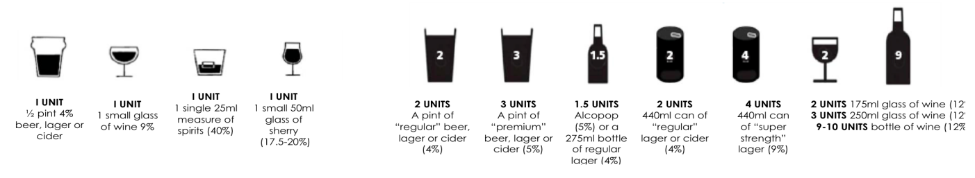
Alcohol Health Questionnaire – Stenhouse Medical Centre
Instructions for Patients:
Please circle the correct answers and then hand into a member of the practice staff.
The unit guide below will help with calculating units.

Questions | Scoring system |  |  |  |  | Total
 | 0 | 1 | 2 | 3 | 4
1. How often do you have a drink containing alcohol? | Never | Monthly  or less | 2-4 times per month | 2-3 times per week | 4+ times per week
2. How many units of alcohol do you drink on a typical day when you are drinking? (See unit guidance above.) | 1 -2 | 3-4 | 5-6 | 7-9 | 10+
3. How often have you had 6 or more units if female, or 8 or more if male, on a single occasion in the last year? | Never | Less than monthly | Monthly | Weekly | Daily or almost daily
4. How often during the last year have you found that you were not able to stop drinking once you had started? | Never | Less than monthly | Monthly | Weekly | Daily or almost daily
5. How often during the last year have you failed to do what was normally expected from you because of your drinking? | Never | Less than monthly | Monthly | Weekly | Daily or almost daily
6. How often during the last year have you needed an alcoholic drink in the morning to get yourself going after a heavy drinking session? | Never | Less than monthly | Monthly | Weekly | Daily or almost daily
7. How often during the last year have you had a feeling of guilt or remorse after drinking? | Never | Less than monthly | Monthly | Weekly | Daily or almost daily
8. How often during the last year have you been unable to remember what happened the night before because you had been drinking? | Never | Less than monthly | Monthly | Weekly | Daily or almost daily
9. Have you or somebody else been injured as a result of your drinking? | No |  | Yes, but not in the last year |  | Yes, during the last year
10. Has a relative or friend, doctor or other health worker been concerned about your drinking or suggested that you cut down? | No |  | Yes, but not in the last year |  | Yes, during the last year
Total _____

Assistance During Appointments
In order for us to provide you with any assistance you may require during consultations, please let us know if you would benefit from any of the following:-

First Language NOT English – require a translator
Deafness – require a sign language translator
Disability – require a carer

Summary Care Record

NHS Healthcare Staff caring for you may not be aware of your current medication, allergies you suffer from and any bad reactions to medicines you have had, in order to treat you safely in an emergency.

If you would like to have a summary care record in place that can be accessed by healthcare staff, then please state so below.

I wish to have a summary care record
I do not wish to have a summary care record

Feedback Information

How did you hear about Stenhouse Medical Centre?

Practice Website | Facebook | Recommended by Someone
NHS Choices Website | Word of Mouth | Other (please state)

I believe all of the information in my new patient health questionnaire to be accurate and correct to the best of my knowledge (please sign, print and date below)

Sign: _______________________ Print: ____________________ Date: __________________

For Office Use:

Form taken by –

Sign: _______________________ Print: ____________________ Date: __________________

Consent Form

I, ………………………………………………………., have today been given the opportunity to discuss sharing of my patient record and have read and understood the leaflet “Your electronic patient record & the sharing of information”

I understand that the same record is used to store information recorded by different members of the care teams who are currently involved in providing my care, including but not limited to doctors surgeries, district nurses, health visitors, physiotherapists, podiatrists, social care and child health. I understand that I will be asked to give consent by each care team before they are able to access or add to any shared data about me.

Share-out

I would* / would-not* like the information recorded at Stenhouse Medical Centre to be available to be seen by other care teams who are involved in my care where I have granted those care teams access to see my shared data.

Share-in

I would* / would-not* like the information recorded at other care teams who are involved in my care to be seen by members of the team at Stenhouse Medical Centre, where I have granted those care teams the right to add to my shared data.

* Delete as appropriate

I understand that I can change my decision at any time.

Signed ____________________________

Patient ……………………………………… Date of Birth …………………………

Print Name …………………………………… Todays date ……………………………

OR

Patient representative ……………………………………

Relationship to patient ……………………………………

Application for online access to my medical record

I wish to have access to the following online services (please tick all that apply):

- Booking Appointments

- Requesting repeat prescriptions

- Summary Record Access

- Detailed Coded Record Access

- Full Clinical Record from 1st April 2019

I wish to access my medical record online and understand and agree with each statement (tick)

- I have read and understood the information leaflet provided by the practice

- I will be responsible for the security of the information that I see or download

- If I choose to share my information with anyone else, this is at my own risk

- I will contact the practice as soon as possible if I suspect that my account has been accessed by someone without my agreement

- If I see information in my record that is not about me or is inaccurate, I will contact the practice as soon as possible

- If I think that I may come under pressure to give access to someone else unwillingly I will contact the practice as soon as possible.

FOR PRACTICE USE ONLY

Patient NHS number |  | Identity verified by  (Name)
 | Date | Method Vouching  Vouching with information in record  Photo ID and proof of residence
Authorised by |  |  |  | Date
Date account created

Date passphrase sent

Level of record access enabled  Prospective  Retrospective  All  Limited parts  Contractual minimum |  |  | Notes / explanation

Patient Consent for Email and Text Message Communication

The practice wishes to expand its methods of communicating with patients to include the use of email and text messaging.

Patient Privacy is important to us, and Stenhouse Medical Centre would like to communicate with
you regarding any activities that may be of interest, which means that we need your consent.

This may include using emails to provide updates on new developments at the practice, and the use of text messaging to send patients reminders about the details of their next appointment, practice news, and for the purposes of health promotion.

Emails and text messages are generated using a secure facility, but because they are transmitted over a public network they may not be secure. Email and text communication will never be used for urgent communications. Your contact details will be used solely in relation to healthcare services offered by the practice, and you can choose to opt out of the services at any time by contacting Melanie Yorke, Practice Business Manager.

Please complete this form and hand it in at the practice reception
if you consent to any, or all, of the above.

Patient Name |  | Date of Birth | ………./………./……….
Mobile |  | Consent to use? | Y | N
Email |  | Consent to use? | Y | N
Home Telephone
Signature |  | Date

Where a patient does not grant consent then the Practice will not be able to use their personal data.

For Practice Use Only

Checked By (Initials)
Registration form completed & signed
Ethnicity completed
Alcohol screening questions completed
Smoking status completed
Summary Care Record completed
ID verified and photocopied
Online access required & signed
Consent for SMS & email - signed

For Management Use

Needs an appointment with:

HCA Diabetes Nurse
Date: No Action Respiratory Nurse
Name: Recalls Added Doctor
Under 19’s
HV Informed

